 |  | Document No: AP-025  Title: Test functionality in Evaluation Build GUI 4.12.01 Eval |  | Date: 05 Nov 2008
Engineering Application Notes
Authors |  |  | Revision Status | Page | Of
Dennis Goh |  |  | 1.0 | 1 | --
Verified By | Date |  | Product | Software Revision
 |  |  | GUI 4.12.01 Eval 8 | After 4.12.01 release

Release History
Revision | Change | Date/ECN #
 | UNRELEASED

Introduction:
This document is a brief description of some R&D code that we want to evaluate in the field. This is relatively untested and the user should understand that this may not be supported going forward. It’s a concept build to get feedback from AE’s and customers to see how much benefit it is.

This code is unreleased, in order to run an Evaluation license must be sourced from dennis_goh@agilent.com; AYARU_ALAGESAN@agilent.com– this will be a time based license.

The new pieces of functionality added to this Eval build that are new over the official GUI4.12.1 Release are:
- New Paste inspection technique to allow the SW learning in the board background during inspection run (Added 5.0 eval 7). User configurable through config.txt (added 5.0 eval 18).
- Warning to inform user if 2D gantry mapping turns itself off as well as enhanced logging in this area of code to capture why this is happening (added 5.0 eval 16).
- “Solder Splash” detection on Memory Module boards (added 5.0 eval 16) for Dark on Bright splashes. Modified in 5.0 eval 43 for Bright on Dark.
- Improved Time stamp functionality where a time stamp file can be taken for up to 4 boards
inspected. (Added 5.0 eval 21)
- Joint the lock to CAD centroid for Bright Box (Added 5.0 eval 22).
- Enhanced logging added to Fid file – specifically for Dual lane fid setup issue (Added 5.0 eval 27).
- Or’ing ability added for Lead ringer (Added 5.0 eval 29).
- Reversible Classifier training – the ability to change the order of the classifier board training so bad (Bare) boards can be trained first – (Added 5.0 eval 29).
- New functionality for Universal Algo and reading Barcode through camera. No error code generated for Barcode misread (Added 5.0 eval 35).
- Enhanced Fail_table functionality to track consecutive Ref. Des. Failures over user defined Panel inspection and Bring up AOF (Added 5.0 eval 36).
- New use model for Dual lane Fid setup (Added 5.0 eval 37).
- OCV Sampling – Ocv sampling based on % OCV models (Added 5.0 eval 38).
- Rotate Part Number or Reference Designator in “Board Tree” view (Added 5.0 eval 43).
- Side fillet for S,R and C and Lead Ringer for S Type now outputted at pin level to joiXXXX.txt file (Added 5.0 eval 43).
- Polarity Bar edge finder- This is a new polarity calculation mode that automatically detects for varying polarity bar on two leaded components such as dark/white tantalum, diode etc. It aims to reduce the amount of fine tuning work required when part supplier changes.
- PLR enhancement- Includes output of U+S type Joints and bridges X/Y coordinates + R, C and T (in addition to the existing S and Z output). Please note – U type joints etc can’t be named using the Pin Layout Editor (it only supports S and Z algorithms). Pins are named according to the row they belong to and their inspection sequence number. (Added 5.0 eval 46, 5.0 eval 47)
- Barcode output disordered with Staging option- For SJ5000 with Staging function, the barcode scanned for respective boards can get displaced if boards are not inspected sequentially resulting in barcode written to wrong boards. This is Fixed in 5.0 eval 49, it is tested working for Single lane but not on duallane machines.
- Enhance camera barcode read for laser etched barcode label ( Added in 5.0 eval 51)
- Addition of side fillet masking (added in 4.12.01 Eval IB3)
- Additional lighting channel in E-type for Pressfit (Added in 4.12.01 Eval IB4)
- Pin Level Reporting- Allow Pin Assignment for U type Joint and Bridging ( Added 4.12.1 Eval IB5)
- Board number graphic Display (Added 4.12.01 Eval 5)
- New Fiducial insertion Feature- this is a wizard tool that allow the insertion of Fiducial that is not provided with the Cad.

Bug Fixes

Barcodes now work with Staging – Previously Barcode information could only be hold for the last barcode scanned and does not support when Board Staging is employed. This has been addressed in 5.0 eval 37. To allow barcode buffering, set “Barcode delay” to “1” under Tools/Barcode manual, Where 1 represents one extra barcode buffered in the memory. Fixed in 5.0 eval 37.
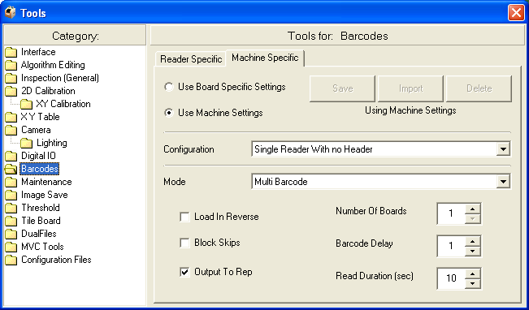

Developer Mode Bug Fixes (Added, retrieved from 5.0 eval 19)
- When using the Multi-inspect functionality and configured to “Stop on Error”. When an error does occur, clicking on the “Edit” button on the resulting dialog box does not take you to the failed component, but takes you to the very first component at the start of the image list.
This mean you will have to find out which component fails, search it out and edit the algorithm. This can take a lot of time when dealing with hundreds of components.

- In the Device editor in developer mode the user is not able to tell what the component failed for. When you select the component with the “Inspect” button, sometimes it does not update in the console saying what this component fail for. Even in the editor, you will still not be able tell what is the failure. The only way to know that this component failed is through running the “Mutli-inspect” and that it STOP because it failed.
Wind Charting (4.12.01 Eval IB5) –Wind charting uses the rep files and the plx&vew files to draw the layout. If the vew file is from machine A and the rep files are from machine B, the component order in them may not match up. The old version displayed the results incorrectly, the new version displays the results correctly. This is mainly useful for AEs or support people who use data form many different sources. People viewing data on the actual machines would have been OK.

Developer mode crashes (Added 4.12.01 Eval IB5) - Manage quadrant image allocation better for offline loading of jpeg and ppm images

E-type Presence Threshold bug( 4.12.01 Eval IB5) - The presence score changes with the presence threshold setting( 4.12.01 Eval IB5). This is now fixed.

PLR fails to generate Erep file- In R/C type algorithm when Side fillet are applied, an extra line is generated in the JOI files with the wrong format. A Temporary fix is to remove these line to produce the Erep file. (Added 4.12.01 Eval 3)

Accuracy improvement on multiple lane machine- This enhancement is for dual and Tri lane machines, correct mapping file are now loaded using gantry location rather then lane number (Added 4.12.02 Eval IB5)

FIS script related-Add outStopBoardsLoading bit to handle PLC related COM calls . (Added 4.12.01 Eval4).

Known Bugs

Eval Functionality Explained:
1. Paste inspection enhancement to allow code to learn in board substrate during production run.

Introduced in 5.0 Eval 7 - This eliminates the need to retrain in different colored board substrates. This is enabled in the config.txt by changing the 2nd parameter on the "global" line from 0 to 9

It should begin "global 1 0 ....."
Change it to "global 1 9 ..."

Board substrate is automatically learned during the first couple of views (user definable – see below) during the inspection (will disappear after this). The first two pixels below the search area in the image below show where the board substrate is being learned.
Automatic Board colour learning
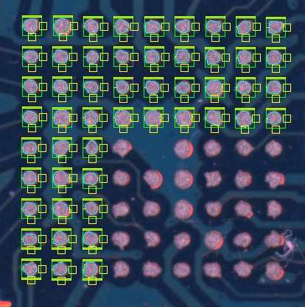

However based on feedback it was discovered in some instances the Sw was learning in the paste as board substrate.
A New entry now added to config.txt in 5.0 eval 18 to have user definable board substrate learning thresholds.

6paste 50 1 2500

Where Parameter “50” - is the grey level threshold for board learning. If SW reads a value below this it will know it’s the board substrate and will not learn it as paste.

Where Parameter “1” - is set to learn as substrate.

Where Parameter “2500” - is SW to learn on first 2500 paste deposits.
In earlier versions, this defaulted to 500 deposits, now it has been made a variable.
It looks like ½ the number pf paste deposits per plx file (roughly) is a good value. Max 8000

2. Warning to inform user if gantry mapping turns itself off as well as enhanced logging in this area of code to capture why this is happening.

A bug has been reported in our 4.12 release of SW, where gantry mapping turns itself on a random basis. This functionality is only required for high end accuracy studies. So far we have been unable to replicate this consistently in house. This functionality tells the user at a glance whether mapping is being used or not.

Also all interaction with the gantry is now written to a newly created log file called “xytable_mapping.log” located under cpi/log.

If Gantry mapping turns itself off, this log file is to be sent in straight away for diagnosis and hopefully bug fix.

To enable Gantry mapping display add the following line to the config.txt =>

MapDsp 1.

This will enable the below display during inspection.

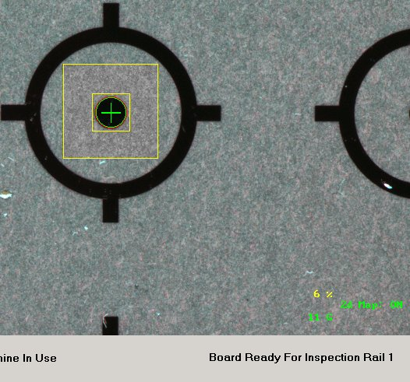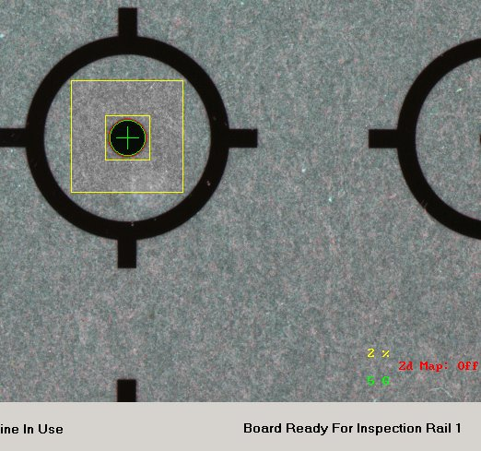

3. “Solder Splash” detection on Memory Module boards.

To Detect Dark on Bright solder splashes

B type to be used to locate on pad.
Using a special feature located in the Joint inspection tab (enabled by "value ending in 2" in the Joint grey level threshold - example 202).
A pixel counter was enabled - threshold was defined in the coverage threshold field - ex 3 for 3 pixels or more.

Lighting channel automatically used is Top plane (Red) + Green channel when this mode is selected.

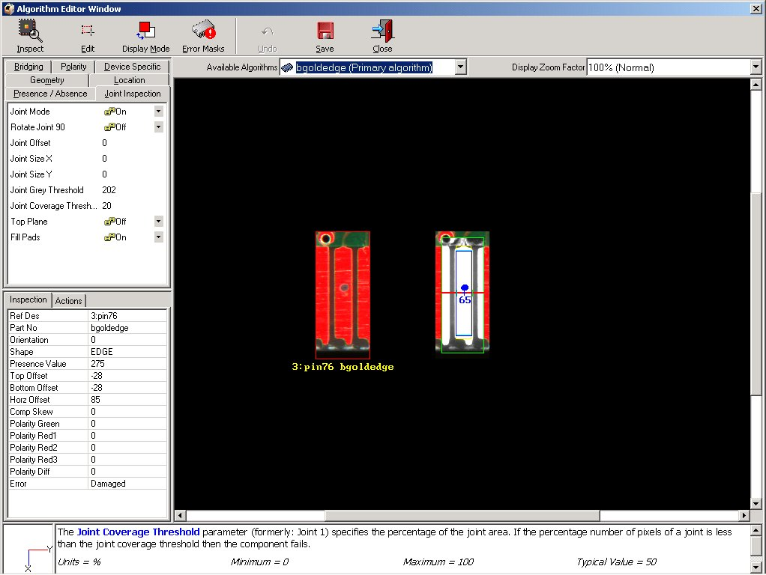
Joint Grey level to end in “2” to enable!!!
Pixel Counter for contamination
Flagged as Damaged during inspection
OLP Sreenshot

To Detect Bright on Dark solder splashes

The SW has now been modified so that in tandem with the above (Dark on bright solder splashes) it can now work with bright splashes on a dark background.

It does this by analysing the connector in the 45 Blue lighting plane.

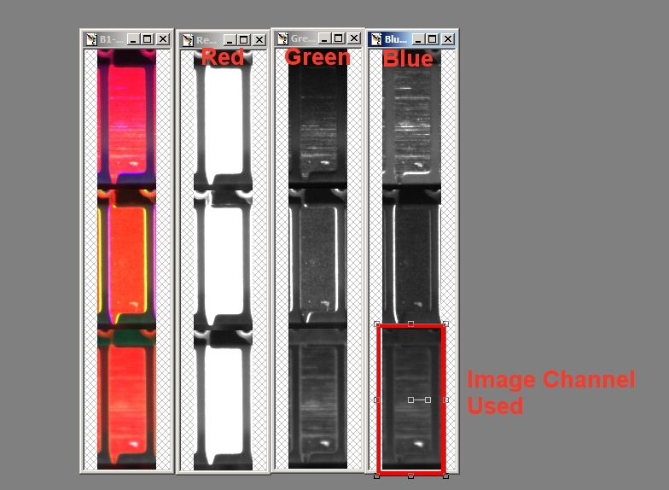

To enable this functionality set an approx value of 60 in the joint offset field.

This is a Grey scale threshold above which the pixels will be counted. Anything above this threshold will be coloured in as Green (The previous dark on bright functionality fills them in as blue).

If there are any scratches on the connector they will appear as thin bright lines. Sw is hardcoded to ignore these by looking for an extra bright pixel above or below this. If none present it will filter these lines out.

System will display two numbers on the screen when using the Algo. The first is the pixel count the other is the mean grey level of the blue channel.

The “Coverage Threshold” previously defined with the Dark on Bright solder splashes is used as error threshold – anything above this and device will fail as damaged.

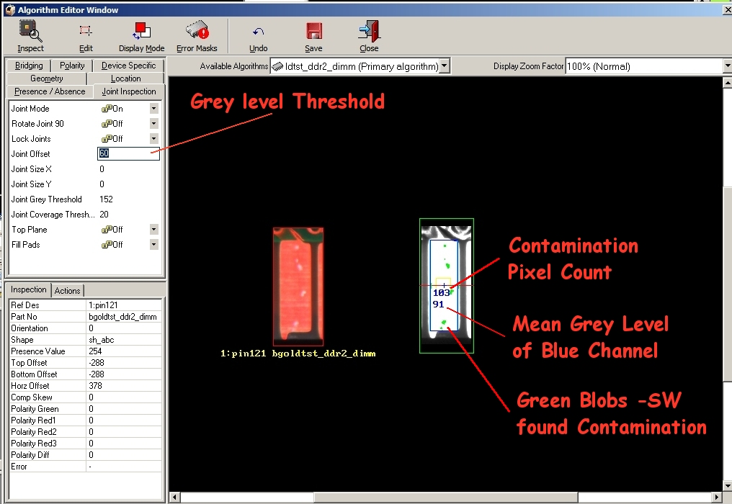

4. Improved Time stamp functionality.
Where a time stamp file can be taken for up to 4 boards inspected. (Added 5.0 eval 21). Generally recommended that this is done over a dynamic R&R. Added so R&D can assess timing over multiple board run.

Tools/Maintenance – create Time stamp file.

5. Joint the lock to CAD centroid for Bright Box (Added 5.0 eval 22).

New drop down option that will lock the Joint check area in relation to the cad centroid and will not move around with CAD location.

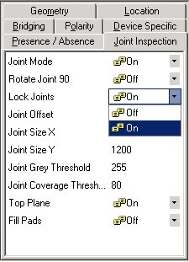

6. Enhanced logging added to Fid file – specifically for Dual lane fid setup issue (Added 5.0 eval 27).

7.Or’ing ability added for Lead ringer (Added 5.0 eval 29).

8. Reversible Classifier training – the ability to change the order of the classifer board training so bad (Bare) boards can be trained first – (Added 5.0 eval 29).

A number of customers/AE’s have requested the ability to have the ability to have the “Bad” board training first for their Classifer training. This is during line change over the customer has to wait for “Good” board to arrive at the SJ.

A new “Check” box has been added to the “SLA Training Wizard” to allow the user to change the order.

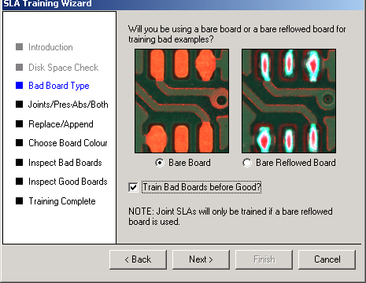

9. New functionality for Universal Algo and reading Barcode through camera. No error code generated for Barcode misread.

This functionality can be used where the Barcode label print quality is not sufficient to achieve a good read through the camera.
A new option has been added to the Universal Algo where a barcode failure will not generate an “Error” code on the rep file.
This means that if “enabled” and an entire board passes component inspection and the Universal “Fails” for barcode inspection – AOF will not be called and the Panel will be sent downstream as a good board.

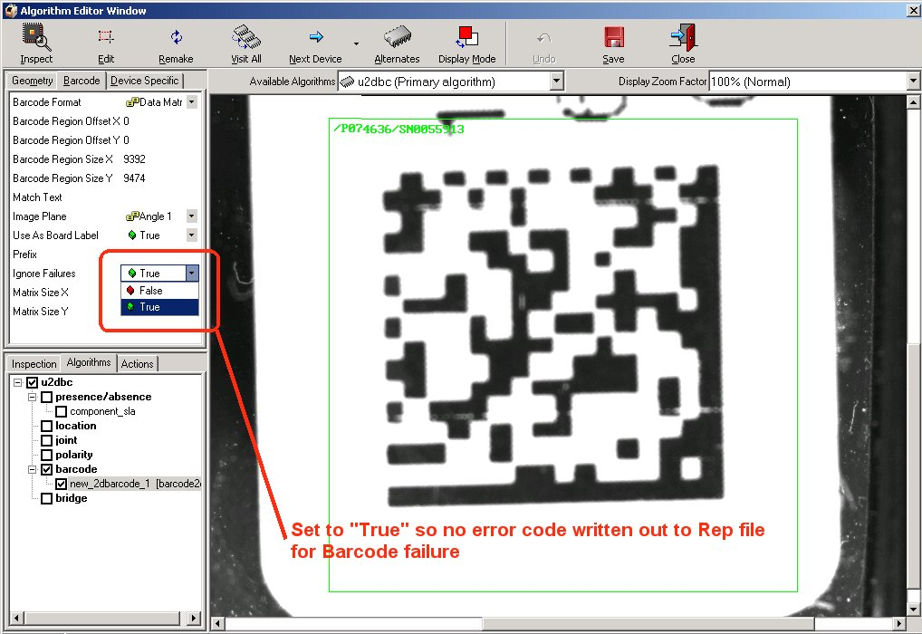

Universal Set-up for “No Error code on Barcode failure”.
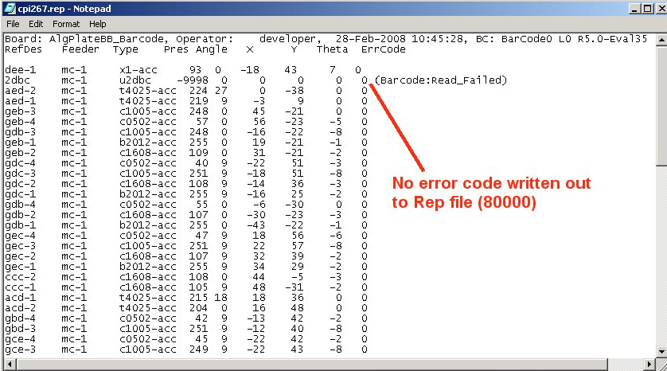

Output to rep file “No Error code on Barcode failure”.

10. Enhanced Fail_table functionality to track consecutive Ref. Des. Failures over user defined Panel inspection and Bring up AOF.

An extra line has been added to the "Fail_table.txt" (See “action_on_Failure_extended” in the config.txt manual) that now allows the user to stop the system if the same Ref. Des. Fails over a user defined amount of boards.

**********************

Missing Skew Offset Polarity OCR OCV Excess Bridging
!all 20 0 0 0 0 0 0 0
!type e 20 0 0 0 0 0 0 0
consecutive_refdes 1 4 *

**********************

Where =>

consecutive_refdes 1 4 *
Field1 Field2 Field3

Field 1
Bit 0 - Leave in place Panel ID so if 1: .... X times will fail - SW is only tracking for example 1:c26, so 4 panels would be inspected before the user is flagged.
Bit 1 - Strip of Board ID 1:, 2:, 3:. SW is stripping out the Board ID, so c26 just has to fail 4 time and user is flagged

Field 2
3 - Defines amount of failures

Field 3
Ref. Des. Definition - can be * for Wild card OR Ref. des. ID (this is dependent on Field 1)
So if wild card is not use it could be

consecutive_refdes 1 4 c26 u14 r14 s16

11. New use model for Dual lane Fid set-up (Added 5.0 eval 37).

There has been a long outstanding issue with the dual lane fiducial setup between Rail 1 and Rail2 where if the fiducial position on Rail 1 was changed to a new location – Rail 2 fiducial position would be changed.

The problem is that once Rail 2 fid position is taught to the system its stored as on offset in the xy_parms.txt file in relation to fid 1 rail 1 position.

This offset has now been decoupled from the fid file and a new method has been implemented for setting up fiducials to make it more robust and less prone to setup errors. This new method will also facilitate the setup of fiducial positions on additional lanes which is planned for sometime in the future.

Boards that have been previously setup on the dual lane system do not have to re-taught.

New Dual Lane fid setup Use Model.

Step 1 - is to tell the SW what lane is currently “Active”. Where Lane 1 is defined as the lane closest to user. By telling system that Lane 1 is Active - the SW is locked to that lane.

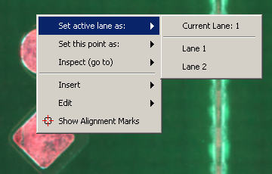

Step 2 – is for user to define fiducial location for the board loaded in the active current lane.

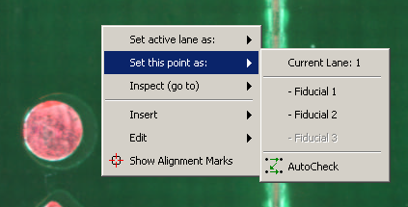

Step 3 – User to confirm fiducial location by using the Goto option.

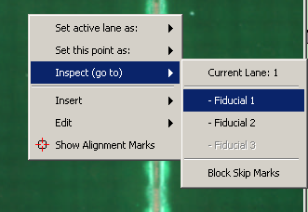

Step 4 – Repeat for Lane 2.

Fiducials now setup for both lanes.

*Note – System will always treat “Active Lane” as lane currently being worked on. However if user has Active lane set as 1, with board present on lane 2, “Eject” will eject board on lane 2 after getting users confirmation.

12. OCV Sampling

OCV sampling added to reduce FF. % Sample rate is applied on a per model basis.
If there is only one component’s associated with a model and a sample rate of 25% is applied – this means that it will only be sampled once in 4 inspections.

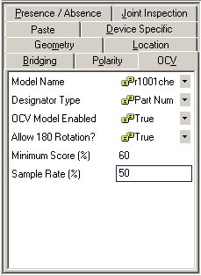

13.Rotate Part Number or Reference Designator in “Board Tree” view (Added 5.0 eval
43).

Note: Component rotation cannot be performed on Split Component.

At the Board Tree View, click on a Part Number or a Reference Designator. Right click and select “Rotate Component” as shown below.

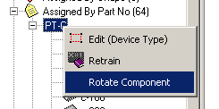
Right click at Part Number

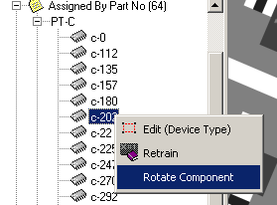
Right click at Reference Designator

When the user select “Rotate Component” after right click at the Part Number, a “Rotate Component” window will be displayed. The part number that will be rotated will be shown in the text “Rotating Part Number PT-C”.
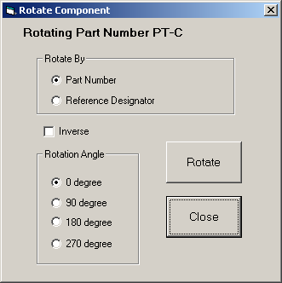

When the user select “Rotate Component” after right click at the Reference Designator, a “Rotate Component” window will be displayed. The Reference Designator that will be rotated will be shown in the text “Rotating Reference Designator c-202”.

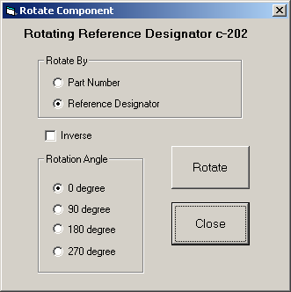

In the window, the user can choose to rotate by Part Number or Reference Designator. If the Part Number is chose, all reference designator under this Part Number will be rotated. If Reference Designator is chose, only this particular Reference Designator will be rotated. In the case of multi board panel, the Reference Designator in other boards in the same panel will not be rotated.
The user can choose to inverse the orientation of this component if the orientation of rotation in the user’s CAD is different from the SJ’s rotation orientation. SJ’s CAD rotation orientation is counter clock wise. To inverse, just check the “Inverse” check box.
Then the user can choose the Rotation Angle among 0, 90, 180 or 270 degrees.
Press Rotate button to perform the rotation.

After the rotation is done, a message box will be displayed asking the user want to proceed to remake CAD or not. Press “Yes” to remake the CAD when you have no more components to be rotated. Press “No” if you have some more components to be rotated. The user must remember to remake CAD after the rotations are done so that we can correct view information because some time a component will move to other view after it is rotated.

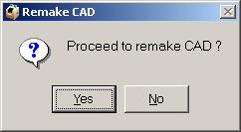

The “Rotate Component” window can also be opened through the “Rotate” button at the toolbar in the Algorithm Editor window as shown below.

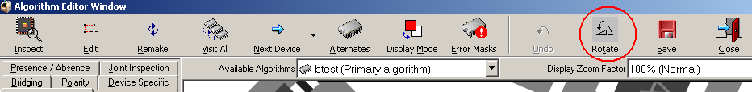

After the component rotation is done, you will see that the orientation angle is updated in the Component Information interface.

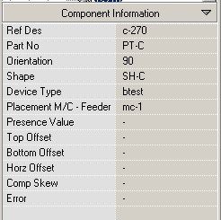

The orientation angle in the .plx, .pls and .vew files will be updated as well.

14. Side fillet for S,R and C and Lead Ringer for S Type now outputted at pin level to joiXXXX.txt file.

Side fillet for S,R and C and Lead Ringer for S Type now outputted at pin level to joiXXXX.txt file.

15. Polarity Bar edge finder- This is a new polarity calculation mode that automatically detects for varying polarity bar on two leaded components such as dark/bright tantalum, diode etc. It aims to reduce the amount of fine tuning work required when part supplier changes.

This is a new polarity calculation mode that automatically detects for varying polarity bar on two leaded components such as dark/bright tantalum, diode etc. It aims to reduce the amount of fine tuning work required when part supplier changes.
It is based on locating the edge of a polarity "bar" mark and returns a score based on the largest number of edge points in a row as shown. [Previous modes mainly used the mean intensity of a region]
It differs from other Polarity modes in that it should not require alternates - it has an automatic sequence of alternates that are activated in a given order. A single test works for dark or bright components, and requires no threshold setting. The user only has to set the check region. It works in 2 box and 4 box mode, and with specific Red box offsets.
To enable;
- Set Calculation Mode to "Bar Edge Find" in the polarity tab.
- Set the Polarity Image Plane to "Angle 1"
- Set up the polarity check regions to be almost the full width of the component - to emphasise the width of the polarity bar in contrast to narrow lines in text or legending.
- Position the check regions to cover the edge of the polarity bar (not the whole bar). This means the regions will probably be nearer to the centre of the component than usual.
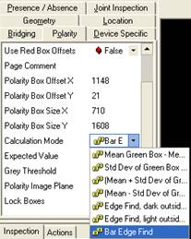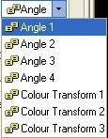
Operation
The edges found will be shown in yellow inside the red and green boxes.
The edge scores are printed in light blue beside the boxes. There is no user settable edge threshold
Note the green cross showing the location of the edge in the green box. This position will be displayed in the green box if the score is > 20.
Passing/failing is as for normal polarity.
Recheck 1
If the score is < 10 for both boxes, the system retries with a lower edge threshold. In this case, you will see a second number displayed in light blue above. It should be larger than the first. This is often sufficient to find a dim edge.
Recheck 2
In the case that both numbers are still < 10, the system retries with the Current "Polarity Image Plane" - which should be angle 1. In this case, there will be a 3rd number displayed, and the edges will be displayed in pink (as shown).
The check is performed in the red channel (Angle 1), with the centre set to bright - this has been found to be necessary, but we cannot be sure it will work all the time.
There is no way to enable to disable either of the rechecks.
Automatic Light/Dark Detection
The algorithm will select dark body or bright body by checking the centre of the component in the red image plane, and if it is > 150 grey levels, the body is considered bright, and if <= 150, it is considered dark.
Thus, the system should be able to switch between green and black tantalums if required.
The grey level is printed on the screen, and the box is also drawn when in the editor.
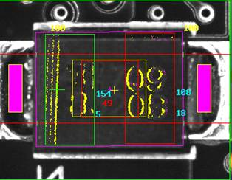

16. PLR enhancement- Includes Erep file output of U+S type Joints and bridges X/Y coordinates + R, C and T (in addition to the existing S and Z output). Please note – U type joints etc can’t be named using the Pin Layout Editor (it only supports S and Z algorithms). Pins are named according to the row they belong to and their inspection sequence number. (Added 5.0 eval 46, 5.0 eval 47)

17. Barcode output disordered with Staging- For SJ5000 with Staging function, the barcode scanned for respective boards can get displaced if boards are not inspected sequentially resulting in barcode written to wrong boards. This is Fixed in 5.0 eval 49, it is tested working for Single lane but not on duallane machines.

18. Enhance camera barcode read for laser etched barcode label ( Added in 5.0 eval 51).

Barcode Erosion and Smooth

Two new image pre-process parameters are added in barcode algorithm.

- Erosion
- Smooth

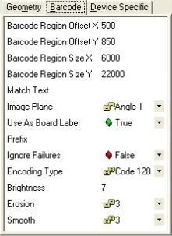

There will be several levels of Erosion value which are 3, 5, 7, 9 and 11. The default value is 0 (no erosion).

Also, there will be several levels of Smooth value which are 3, 5, 7, 9, 11, 13 and 15. The default value is 0 (no smooth).

Definition of Erosion Image Processing

Thin the white objects by removing one layer of pixels along the white object edges. When the kernel size gets large, the tiny white objects completely disappear and the black ones get fatter.

Definition of Smooth Image Processing

Smoothing the edges and reduce image noise

The Use of Erosion on Barcode Reading

Erosion preprocesses help to repair some of the very bad condition barcode like example below:

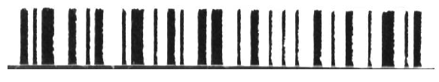

Barcode element edges are jittering/varying a lot with ink jet or dot matrix printers.

Below is the barcode image after erosion image preprocessing:
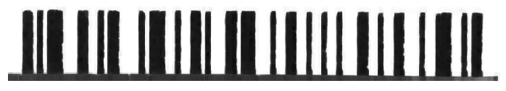

The Use of Smooth on Barcode Reading

Smooth method is helping to smoothing the edge of barcode elements. The jitters of element edges will be reduced.

Before Smooth:
After Smooth:
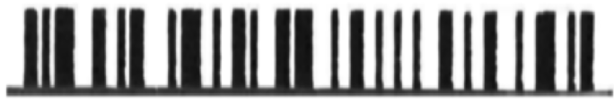

Also, it helps to reduce the unwanted noise like in image:

Before Smooth:

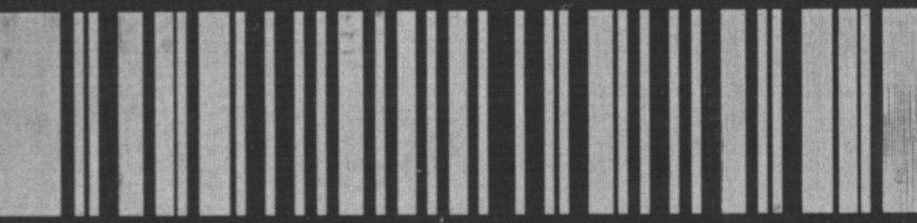

After Smooth:

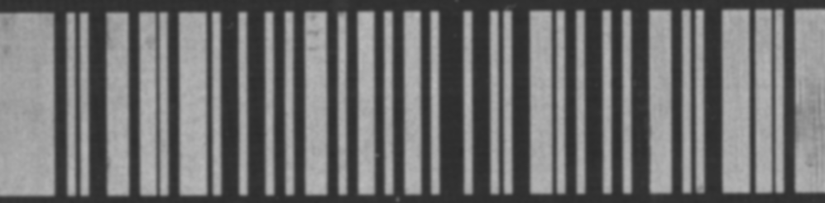

19. Addition of side fillet masking (added in 4.12.01 Eval IB3)

In this release, masking applies to failed Toe Joints, bridging and Side Fillet errors.

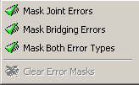
Old masking menu

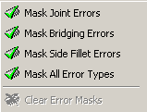
New masking menu

Files affected

Note that modification is made to the “Board_name.skip” file in the \cpi\cad\ folder.

An example from the masking list in the <BoardName>.skip file:

s 0:rp1 0 AJHI@H@ <>
s 0:rp1 2 I@@ABHH <>
s 1:rp2 1 @B@@B@@ <>
s 1:rp2 3 KBKKBB@ <>

Masking character reference Table:

Masking Character | Joint | Bridging | Side Fillet
@ | - | - | -
A | ON | - | -
B | - | ON | -
C | ON | ON | -
H | - | - | ON
I | ON | - | ON
J | - | ON | ON
K | ON | ON | ON

20. Additional lighting channel, angle 3 & 4 for E-type (Added in 4.12.01 Eval IB4)

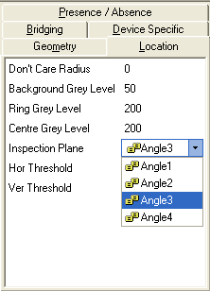

Angle 3 & 4 are added into the Lighting channel, this enhance the visibility of the pin and thus provide better detection for bent Pins.

21. Pin Level Reporting- Pin Assignment for U type ( Added 4.12.1 Eval IB5)

The U-type algorithm can now be use to generate Pin numbers for row of joint/bridge boxes.

Following are new parameter to setup pin numbers:

Joint Start Pin Number – This can be any any starting number of that row of joints boxes
Joint inverse Pin Number- Default pin count starts from left and top for horizontal and vertical rows respectively.
Pin count direction for Horizontal Rows
Pin count direction for Vertical Rows

Rows of Joints and Bridge boxes setup
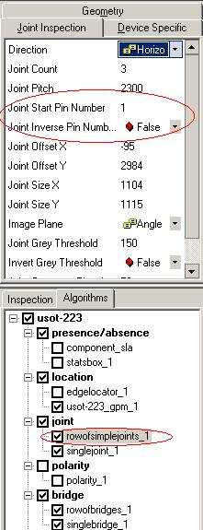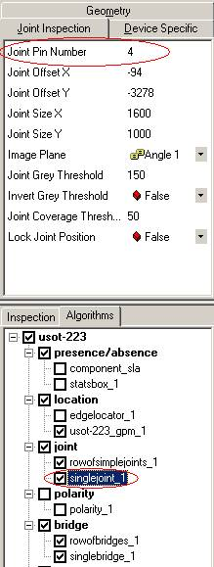

For Single Joint/ Bridge boxes, use the field, “Pin Number” to define the pin number.

Note: if the same Pin number are entered for different rows/Single boxes(see below), it will duplicate accordingly in the output JOI or Erep. This will Not be fix in the near term.
Sample of JOI file
Pin Number

u 2:j3 uconn 4513 183588 J_rowofsimplejoints_1 4 F
u 2:j3 uconn 4513 184375 J_rowofsimplejoints_1 3 F
u 2:j3 uconn 4513 185186 J_rowofsimplejoints_1 2 F
u 2:j3 uconn 4513 185973 J_rowofsimplejoints_1 1 F
Status= F (Fail)

Sample of EREP files
Joint Rows number
<InspRes name="2:j3" result="Fail">
<CompInsp>
<CompDes algType="uconn" ori="0" />
<PlaceDes mc="mc" gantry="0" feederBank="1" feeder="1" head="1" nozzle="" />
<CompInspRes presence="-9998" xOff="0" yOff="0" theta="0" ec="200" es="BadJoint" />
<Pins>
<pinRes name="rowofsimplejoints_1$4" ec="Joint" f="0" d="0" c="0" sf1="0" sf2="0" ringer="Disabled" X="183588" Y="-4513" />
<pinRes name="rowofsimplejoints_1$3" ec="Joint" f="0" d="0" c="0" sf1="0" sf2="0" ringer="Disabled" X="184375" Y="-4513" />
<pinRes name="rowofsimplejoints_1$2" ec="Joint" f="0" d="0" c="0" sf1="0" sf2="0" ringer="Disabled" X="185186" Y="-4513" />
<pinRes name="rowofsimplejoints_1$1" ec="Joint" f="0" d="0" c="0" sf1="0" sf2="0" ringer="Disabled" X="185973" Y="-4513" />

22. Board number graphic Display (Added 4.12.01 Eval 5)

To Enable Board graphic display following the instruction below:

- Add in HKEY_LOCAL_MACHINE\SOFTWARE\MV Technology\GS-1\Display
- Insert new DWORD value ‘BoardNumberDisplay’
- Set value to 0 to disable or 1 to enable

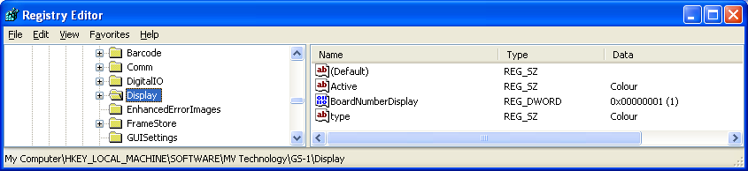
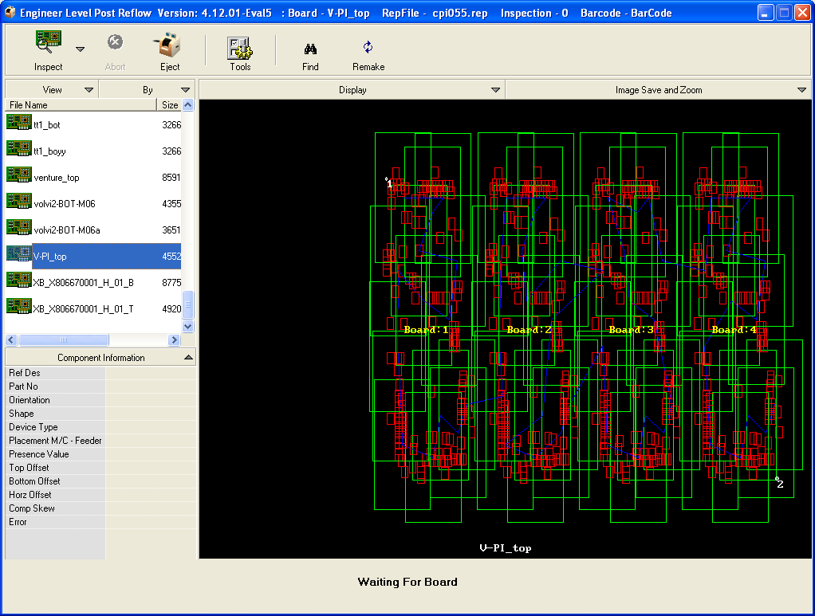

(Note that board identifier in the PLX must begin with “1:” ).

23. New Fiducial insertion Feature- this is a wizard tool that allow the insertion of Fiducial that is not provided with the Cad.

-To launch the Wizard position the camera to a known device listed in the cad and right click to insert Fiducial.

